**POWERS OF THE PLANES EXTENSION 1.2**

ssug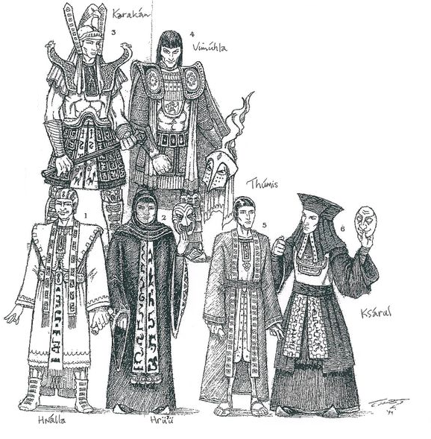

In the interest of simplicity and focusing on the units (not to mention helping Roope’s state of mind) the Powers of the Planes (PoPs) were kept to a minimum in the basic rules. This extension permits players whose tastes run to an, to put it frankly, unhealthy interest in things sorcerous to give full reign to their nastier tendencies (cue sounds of Roope fanning himself).

This extension should be used if players want a more magic heavy game and indulge their unpleasant (and quite possibly illegal) tastes for things demonological (cue sounds of Roope fainting). All references to Powers of the Planes in the main rules are ignored and replaced by this extension.

**PSSS**

A variety of Powers of the Planes may be cast by the wizards and priests (unless their Kerdu is called Roope) of the Command Posts.

1. All PoPs are cast using PSSS.
2. A separate allocation of PSSS available **each turn** is provided in Scenario instructions and is tracked separately (Global Allocation).
3. There will usually be a restriction on the total amount of PSSS that can be used during the battle by each side. This would normally be around 5 x maximum amount usable per turn. Once this is reached no further PoPs may be cast.
4. **PSSS cannot be used for any other purpose** (ie not Commands / Initiative.
5. The availability of PSSS is reduced by 1 for each unit that breaks irrespective of its Quality. Otherwise never changes irrespective of PoP attacks, Hlaka, HQ movement etc. [may review this in due course].
6. Any CP may tap into the Global Allocation. This is relevant due to range effects.
7. PSSS cannot be carried over from turn to turn.
8. If a CP moves voluntarily reduce Global Allocation for the rest of the turn by 25%. If this is more than the currently remaining PSSS in that turn then it cannot move.
9. If a CP displaces due to enemy contact all remaining PSSS that turn are lost, only 50% are available the next, and 25% are lost permanently.

**Casting POPs**

**POPs when using this extension can be cast during the Hlaka Phase and the IAP**.

The Keneng cast a POP takes into account Cost (in PSSS), Range and Duration which are shown against each POP.

**Cost**: This must be paid from available PSSS and recorded on the Command Sheet. It must be paid by a single CP (exception Ghastly Visage of Origob).

**Range**: Standard measurement rules apply.

**Duration**:

**Immediate**: Its effect happens at once and ends.

**Number of turns:** The effect continues for a period.

**Special / Permanent**: Details are set out in the POP description.

1. **POPs cannot be cast after the other Keneng has announced his Commands** in a given Cycle in the IAP, **until** he has executed them (**exception** **Nrainue**). Thus you cannot see if the other Keneng issues a Fire Command and **then** cast Chiming Skulls.

Accordingly Keneng should ensure their opponent has the chance to cast PoPs before announcing Commands. A Keneng may still cast PoPs as he executes his **own** Commands.

**Exception** - If a Missum / Mrugga is cast the enemy Keneng may immediately cast Lascivious Embrace. This is specifically intended to prevent casting M / M and then moving to contact before the enemy can respond. However it is permissible to hit an enemy unit with missile fire attacks, Doomkill etc then move to Contact without the enemy being able to respond with a Lascivious.

1. If both Keneng want to cast a POP at the same time initiative player goes first. PoP casting alternates so the other Keneng may always cast after his opponent casts.
2. **Irrespective of when in a Turn a PoP with duration is cast that turn counts as its first in play.** Thus if a Bluff Cheer is cast in the Melee Phase of a given turn it is removed at the end of the following turn.
3. PoPs may be cast by CPs on any unit, not just those attached to it.

**Recording POPs Activity**

Cards are provided for each SPOP / GPOP. It is essential that Kenengs use the SPOP card to record what was done when. Note on the card (with a preferably delible pen) which turn the SPOP expires. If it is negated rub out these out (hence the delible) but leave the card on the table until the end of the turn so that it is clear another cannot be cast.

**Hogs and POPs**

As noted in the main rules Hogs are highly resistant to magickal tinkerings from effete Priests and weakling Wizards.. Accordingly no Hog may be targeted by a POP except for the Command of Nrainue the Irridescent Empress (refer to the History of the Legion of Guruggma in the DotEG for background). However, they do not affect PoPs cast on other units, and units attacking them using Deadly Missiles, Mighty Fists and Bluff Cheers gain the usual benefits.

Optionally Support POPs may be cast on Hogs but with an immense risk that they will turn on their own command post and cook it.

**Hlaka and Powers**

1. Hlaka may only be targeted by the Flight of the Sro.
2. Optionally Hlaka on All Seeing Eye jf within 700mm of the **target** location increase the range at which any POP can be cast by 50%. [Not sure if the complication here is worth it, for review.]
3. Hlaka harassment of CPs affects their SSS availability but not their PSSS.

**TYPES OF POPS**

PoPs are classified to help Keneng decision making:

**General POPs (GPOPs)**

**Specific POPs** **(SPOPs)**.

**Support / Interfere**

PoPs either Support their own side or Interfere (in a Jimmy Savillesque sort of way) with the enemy. Support cards are marked with a green spot, Interference cards with a black spot.

**Enhancements, Impairments and Removals.**

Enhancements are SPOPs affecting and benefiting friendly units, Impairments are SPOPs affecting and impairing enemy units and Removals remove these first two categories.

Removals negate Enhancements and Impairments. Cards are marked with green spots for Support and black for interference and red for removal to assist Keneng.

**POPs WITH GENERAL EFFECTS (GPOPs)**

These affect the general ability of CPs to function (with the exception of Blackness of Kurritlakal which creates general battlefield obstructions) in various, mostly unpleasant, ways.

**Benison of Ngungethib / Quyove / Shirringayi / (to taste) - Removal / Support**

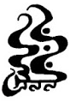

Cost: Variable

Range: **100mm**

Duration: Immediate

Effect: The delicious distraction of Dlamelish, Hrihayal or hot ladies (of no specified gender) from Kaikama etc appears above a CP afflicted with The Hideous Countenance. The CP rolls a QC adding to the roll the number of PSSS committed. **Outcomes**:

GaG: Removes the Countenance which is not permitted to afflict the CP for three turns (including current turn)

EPT: Removes the Countenance. The CP can only be afflicted again by Countenance the **following** turn.

DaD: Fails

GoB: Fails and increases the distance addition to 1000mm

**This may only be cast once per turn on any one Hideous Countenance. It may be cast the same turn the Hideous Countenance is cast.**

**Blackness of Kurritlakal, Eater of Skins - Impairment Interference & Enhancement Support**

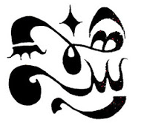

Cost: 3

Range: 1000mm

Duration: 2 turns

Effect: Place a Blackness marker (200mm long, minimal depth) and roll for location. It moves on 4-6 (D6), direction D8, distance D10 x 20mm. **This blocks line of sight for missile units and artillery on the same level as the target**. If closer than 10 cm to a unit they can see through it.

**Sarku** **worshipping units within 10cm of a Blackness get +2 on any QC roll.**

**Any number of these may to be cast in a turn.**

**Fasiltum’s Banded Diorite/Seven Layered Aquesha / Towering Walls of Ssa’atis – Impairment**

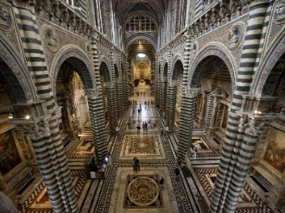

Cost : 4

Range : **1500mm**

Duration : 1 turn

Effect : A spectral wall (of the appropriate appearance) manifests round a target enemy CP. All SPOPs cast by that CP cost double. Other POPs are unaffected.

**Banded Diorite may only be cast on alternate turns on a given CP.**

**Ghastly Visage of Origob - Impairment**

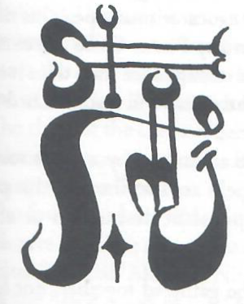

Cost : 7 (may be paid by multiple CPs)

Range : **Entire battlefield**

Duration : 2 turns

Effect : All SPOPs cast by either side cost triple as each Priest and Wizard on the field attempts not to void their bowels in uncontrollable terror.

In addition to the PSSS cost, when casting this PoP the Kening using it has to read out the section in the Book of EBs p23 from “When the Prince leans down” to “as of certain fluids of burning [acids?]”. Certain special restrictions apply to this awfulness:

1. **Only one Ghastly Visage can be in play at any point in time and at least one turn must elapse after its removal before another can be cast**. There is only so much horror mortal flesh and blood can stand. Nothing can remove it once cast. Any Banded Diorite POP in play is removed when Ghastly Visage is cast.
2. **When a Ghastly Visage is cast it must the the first PoP cast that turn by its side**. If a side’s wizards want to try to game the Lord of All Creatures of the Demon Planes by using their spare PoPs first, and then the remainder to call on the Mightiest of All Demons the writer can only wish the souls of their wives and families to the seventh degree the most sincere condolences.
3. **Each side can only cast one Ghastly Visage in the course of the game**.

**Hideous Countenance of Ge’en - Impairment**

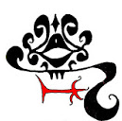

Cost: 5

Range: **1500 mm**

Duration: 2 turns (including turn of summoning)

Effect: An appalling simulacrum of Ge’en appears above an enemy command post, horrifying and terrifying the commanders and their priests. 500mm is added onto the distance of any command issued by that CP, thus increasing the risk of it failing to be received.

**This cannot be cast on a CP already affected. In addition** **it cannot be combined with Unmentionables, the Hlaka do not want to be anywhere near this horror.**

**POPS WITH EFFECTS ON SPECIFIC UNITS (SPOPs)**

**General Restrictions on SPOPs**

**Only two SPOPs** cast by **each side** may apply to a single unit at any point in time. Ie you cannot stack Bluff Cheer **and** Deadly Missiles **and** Diaphanous Veil on a single unit. Nor can you cast Lord Mrugga and Missum and Doomkill on the same target in a single turn. Not can you cast Mrugga and Missum on a legion which already has Dark Doom. Etc. Essentially no gang banging. Unless the scenario rules permit it because, let us say, Princess Ma’in is in attendance to help Prince Dumbo Eselne.

Removals do not count against this.

**If a PoP is negated during a turn:**

1. **It still prevents another identical PoP being cast during the turn** if the PoP description says only one of those PoPs can be cast on a unit at any one point in time. Thus if a Deadly Missile is negated you cannot cast another one on the same unit that turn.
2. **It still counts against maximum two multiturn PoPs limit until it is removed at the end of the turn**. [For review, this is aimed to prevent too many SPOP card piling up by a single unit.]

**If a SPOP is removed in a turn** (ie Dark Doom is removed by the Blessing) then the **same** SPOP cannot be cast on the target that same turn. As noted in the descriptions a Removal PoP can generally not be cast the same turn as the PoP it is removing, so you always get one turn of the enhancement / impairment.

A number of these SPOPs are cannot be cast on units in contact. These are noted in the SPOP descriptions.

**Specific Restrictions on SPOPs**

Each SPOP has specific restrictions (number that can be cast on a unit, when they can be cast etc). These should be read carefully; differences are intentional (I hope!).

Units considered Flame / Sarku worshipping will be determined in each scenario but the baseline is set out in the unit cards / tags.

**SPOPS SUPPORTING FRIENDLY UNITS**

**Beast without a Tail - Removal**



Cost : 1

Range : 1000

Duration : Immediate

Effect : Removes the Glutinous Fluids of Nere

**This cannot be cast the same turn as the Glutinous Fluids.**

**Benison of Avanthe - Removal**

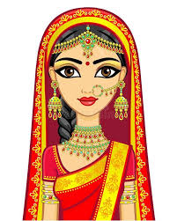

Cost : 2

Range : 100

Duration : Immediate

Effect : The beauteous form of Sunrudaya, the Young Bride aspect of Avanthe appears and the Hideous Countenance of Ge’en is removed.

**Blessing of Empress Ninue Jalesa, Maiden of Beauty - Removal**



Cost : 1

Range : 1000

Duration : Immediate

Effect : The ghostly form of Empress Ninue appears and Dark Doom is removed.

**This cannot be cast the same turn as the Dark Doom.**

**Bluff Cheer of Hagarr of Paranta - Enhancement**



Cost : 1

Range : 1000

Duration : 2 turns

Effect : Increases Quality Level of unit by one step ie Fodder to Fighter but may never increase it to Slayer unless it actually is Slayer (ie negating Savage Bite of Ssussu).

**Two Bluff Cheers apply to a unit and each takes effect**.

**Cleansing Blade of Vimuhla - Removal**

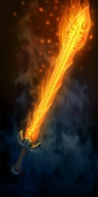

Cost : 1

Range : 1000mm

Duration : Immediate

Effect : A blinding flash of Vimuhlan fire clears the minds of legion staff pondering the Recondite Obscurities. The Obscurities is negated and removed.

**This cannot be cast the same turn as the Recondite Obscurities.**

**Darkness of Gereshma’a, He of the Mound of Skulls - Enhancement**



Cost: 2 SSS

Range: 1000mm

Duration: 2 turns

Effect: If cast on a **Sarku** worshipping unit they receive +3 on any QC or Melee roll, are never shaken (treat as Disordered) and only break like Fanatics. The + 3 on QC is in addition to the + 2 received from the Blackness of Kurritlakal if within range.

If a unit is at break point but is not breaking because of the Fanatic benefit of this PoP it breaks at the start of the next melee phase after it is removed. Thus if it lapses due to end of turn clean up the unit will break at the start of the melee phase in the next turn unless CH are removes / the PoP is cast again. If it lapses due to Removal PoP being played during the turn (before the melee phase starts) then the unit breaks at the start of the melee phase that turn.

**Only one Darkness can be cast on a unit at any one point in time.**

**Deadly Missiles of Pendarte of Kheiris - Enhancement**

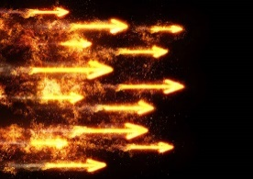

Cost : 2

Range : 1000mm

Duration : 2 turns

Effect : Glittering shards fills the air around two chosen units. When they Fire add 15 to their missile attack strength (not applicable to Artillery). This 15 is fixed and unaffected by the firing unit’s formation. The units do not need to be near each other.

**Only one Deadly Missiles can be cast on a unit at any one point in time. It cannot be cast on a unit affected by Dark Doom of Ssuganar.**

**Diaphanous Veil of Ulela, She of the Thousand Acts of Lubricity - Enhancement**

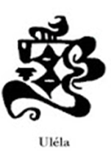

Cost : 2

Range : 1000mm

Duration : Lasts until dispelled or until unit engages in melee combat

Effect : Swirling green and purple shimmers around a chosen unit, with sights of almost unbearable eroticism hanging tantalisingly at the edge of vision. The unit on which it is cast has -**6 bender** vs incoming missile fire (including Doomkill).

**Only one Diaphanous Veil can be cast on a unit at any one point in time.**

**Excrescence of Gashtene - Removal**



Cost : 1

Range : 1000mm

Duration : Immediate

Effect : A vast grey excrescence with four gruesome eyes appears above roiling waves and removes Blazing Light**.**

**This cannot be cast the same turn as the Blazing Light.**

**Ghastly Touch of Srukarum / Black Qarqa - Enhancement**

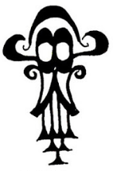

Cost: 5 SSS

Range: 1000mm

Duration: Permanent

Effect: A unit related to Sarku (such as the repellent Scales of Brown or Black Qarqa) may move to an area of the board where a unit was broken and re-animate the bodies to form a unit of Mrur attached to the summoning legion. The animating unit must be within 100mm of the break area (mark as desired).

**Only one Ghastly Touch can be applied per broken unit and only one per benefitting unit. The card should be left on the unit and it counts against the limit of 2 multi turn POPs per unit.**

**Impatient Anger of the Vriddi / Faithful of Hrsh / Avengers of Yilrana - Enhancement**

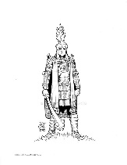

Cost : 4

Range : 1000mm

Duration : Immediate

Effect : Selected unit may take a **fourth** (but no more) action of any sort (including a second Move, a third Fire etc). No further SSS is required for this action [note this gives some capability to slip PSSS into SSS.] Once it is cast on a unit that unit may receive no futher commands that turn. Only one may be cast on a unit each turn.

**Innocence of Dilinala, Lovely Maiden of the Turquoise Crown - Removal**

Cost : 2

Range : 1000mm

Duration : Immediate

Effect : A demure maiden of great beauty and demure purity appears above a unit afflicted by the Diaphanous Veil of Paiya, which disappears.

**This cannot be cast the same turn as the Diaphanous Veil of Paiya**

**Lascivious Embrace of Dashiluna the Green Eyed - Enhancement**

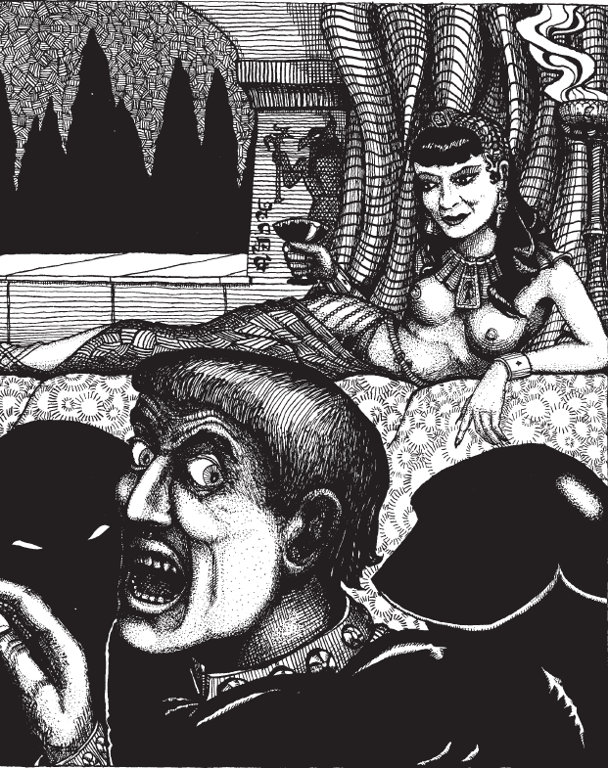

Cost : 2

Range : 1000mm

Duration : Immediate

Effect : The form of the Empress Dashiluna appears, soft sensations of delicious [lengthy section about her imaginative orgies and other curious habits redacted in the interests of good taste] embrace a chosen unit. It removes one Melee / Missile Cohesion Hits **OR** two other CH. [spot the author fine tuning effects]

**Only one Lascivious Embrace can be cast on a unit in one Turn and it may not be used on a unit in contact.**

**It may be used during the opposing Keneng’s cycle but only immediately after a Missum or a Mrugga has been cast.**

**Mighty Fists of Hrugga - Enhancement**

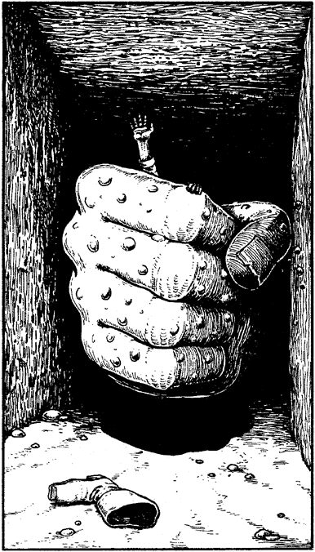

Cost : 2

Range : 1000mm

Duration : 2 turns

Effect : Barely visible fists of irresistible force beat terrifyingly around a chosen unit. You may add 20 to its Melee Attack or Defence rating but not both. This is chosen when the Fists is cast, marked on its card and cannot be changed. The + 20 on Melee Attack is fixed and is not multiplied by the Formation vs Formation table.

**Only one Mighty Fists can be cast on a unit at any one point in time. It cannot be cast on a unit affected by Dark Doom of Ssuganar.**

**Ssudune the Ravener / Ru’utlanesh Hairy Legged Mouth – Enhancement**

  

Cost: 2 SSS

Range: 1000mm

Duration: 2 turns

Effect: If cast on a Flame unit this has +3 on QC and Melee rolls, is never shaken (treat as Disordered) and only break like Fanatics. If cast on an Orange unit (Karakan / Chegarras) they are not treated as Fanatics but get + 3 and are never shaken.

If cast as Ru’utlanesh it gives the same benefit to Green (Dlamelish and Hryihayal) units.

If a unit is at break point but is not breaking because of the Fanatic benefit of this PoP it breaks at the start of the next melee phase after it is removed. Thus if it lapses due to end of turn clean up the unit will break at the start of the melee phase in the next turn unless CH are removes / the PoP is cast again. If it lapses due to Removal PoP being played during the turn (before the melee phase starts) then the unit breaks at the start of the melee phase that turn.

**Only one Ssudune can be cast on a unit at any one point in time.**

**INTERFERING WITH ENEMY UNITS**

**Blazing Light of Jnek’sha, Scythe of Flame - Impairment**

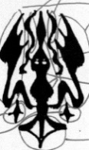

Cost: 2 SSS

Range: 1000mm

Duration: 2 turns

Effect: If cast on a Sarku unit this has - 4 on QC rolls for two turns (2 SSS). See also Mrur special rules (O8).

**Only one Blazing Light can be cast on a unit at any one point in time.**

**Chiming Skulls of Fasiltum / Proclamations of the Four Palaces / Call of Yilrana - Removal**

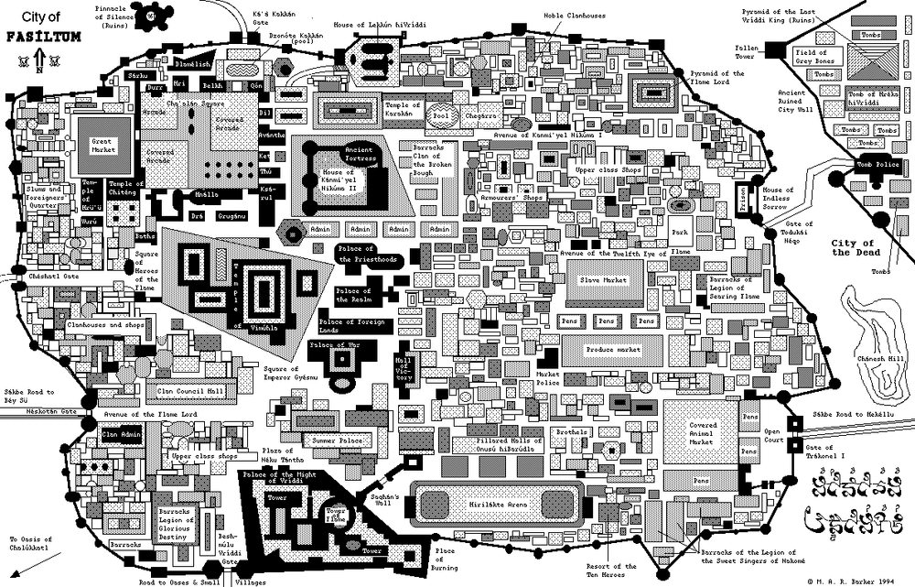 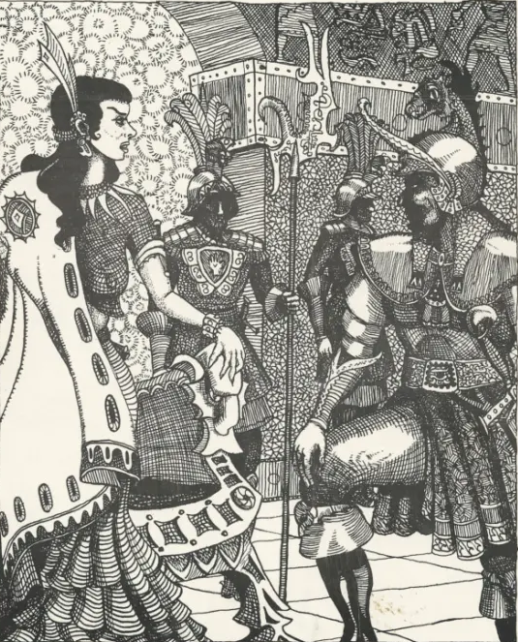

Cost : 1

Range : 1000mm

Duration : Immediate

Effect : Removes up to two Deadly Missiles of Pendarte within range.

**This cannot be cast the same turn as the Deadly Missiles**

**Command of Aleya the Damsel of Purity - Impairment**

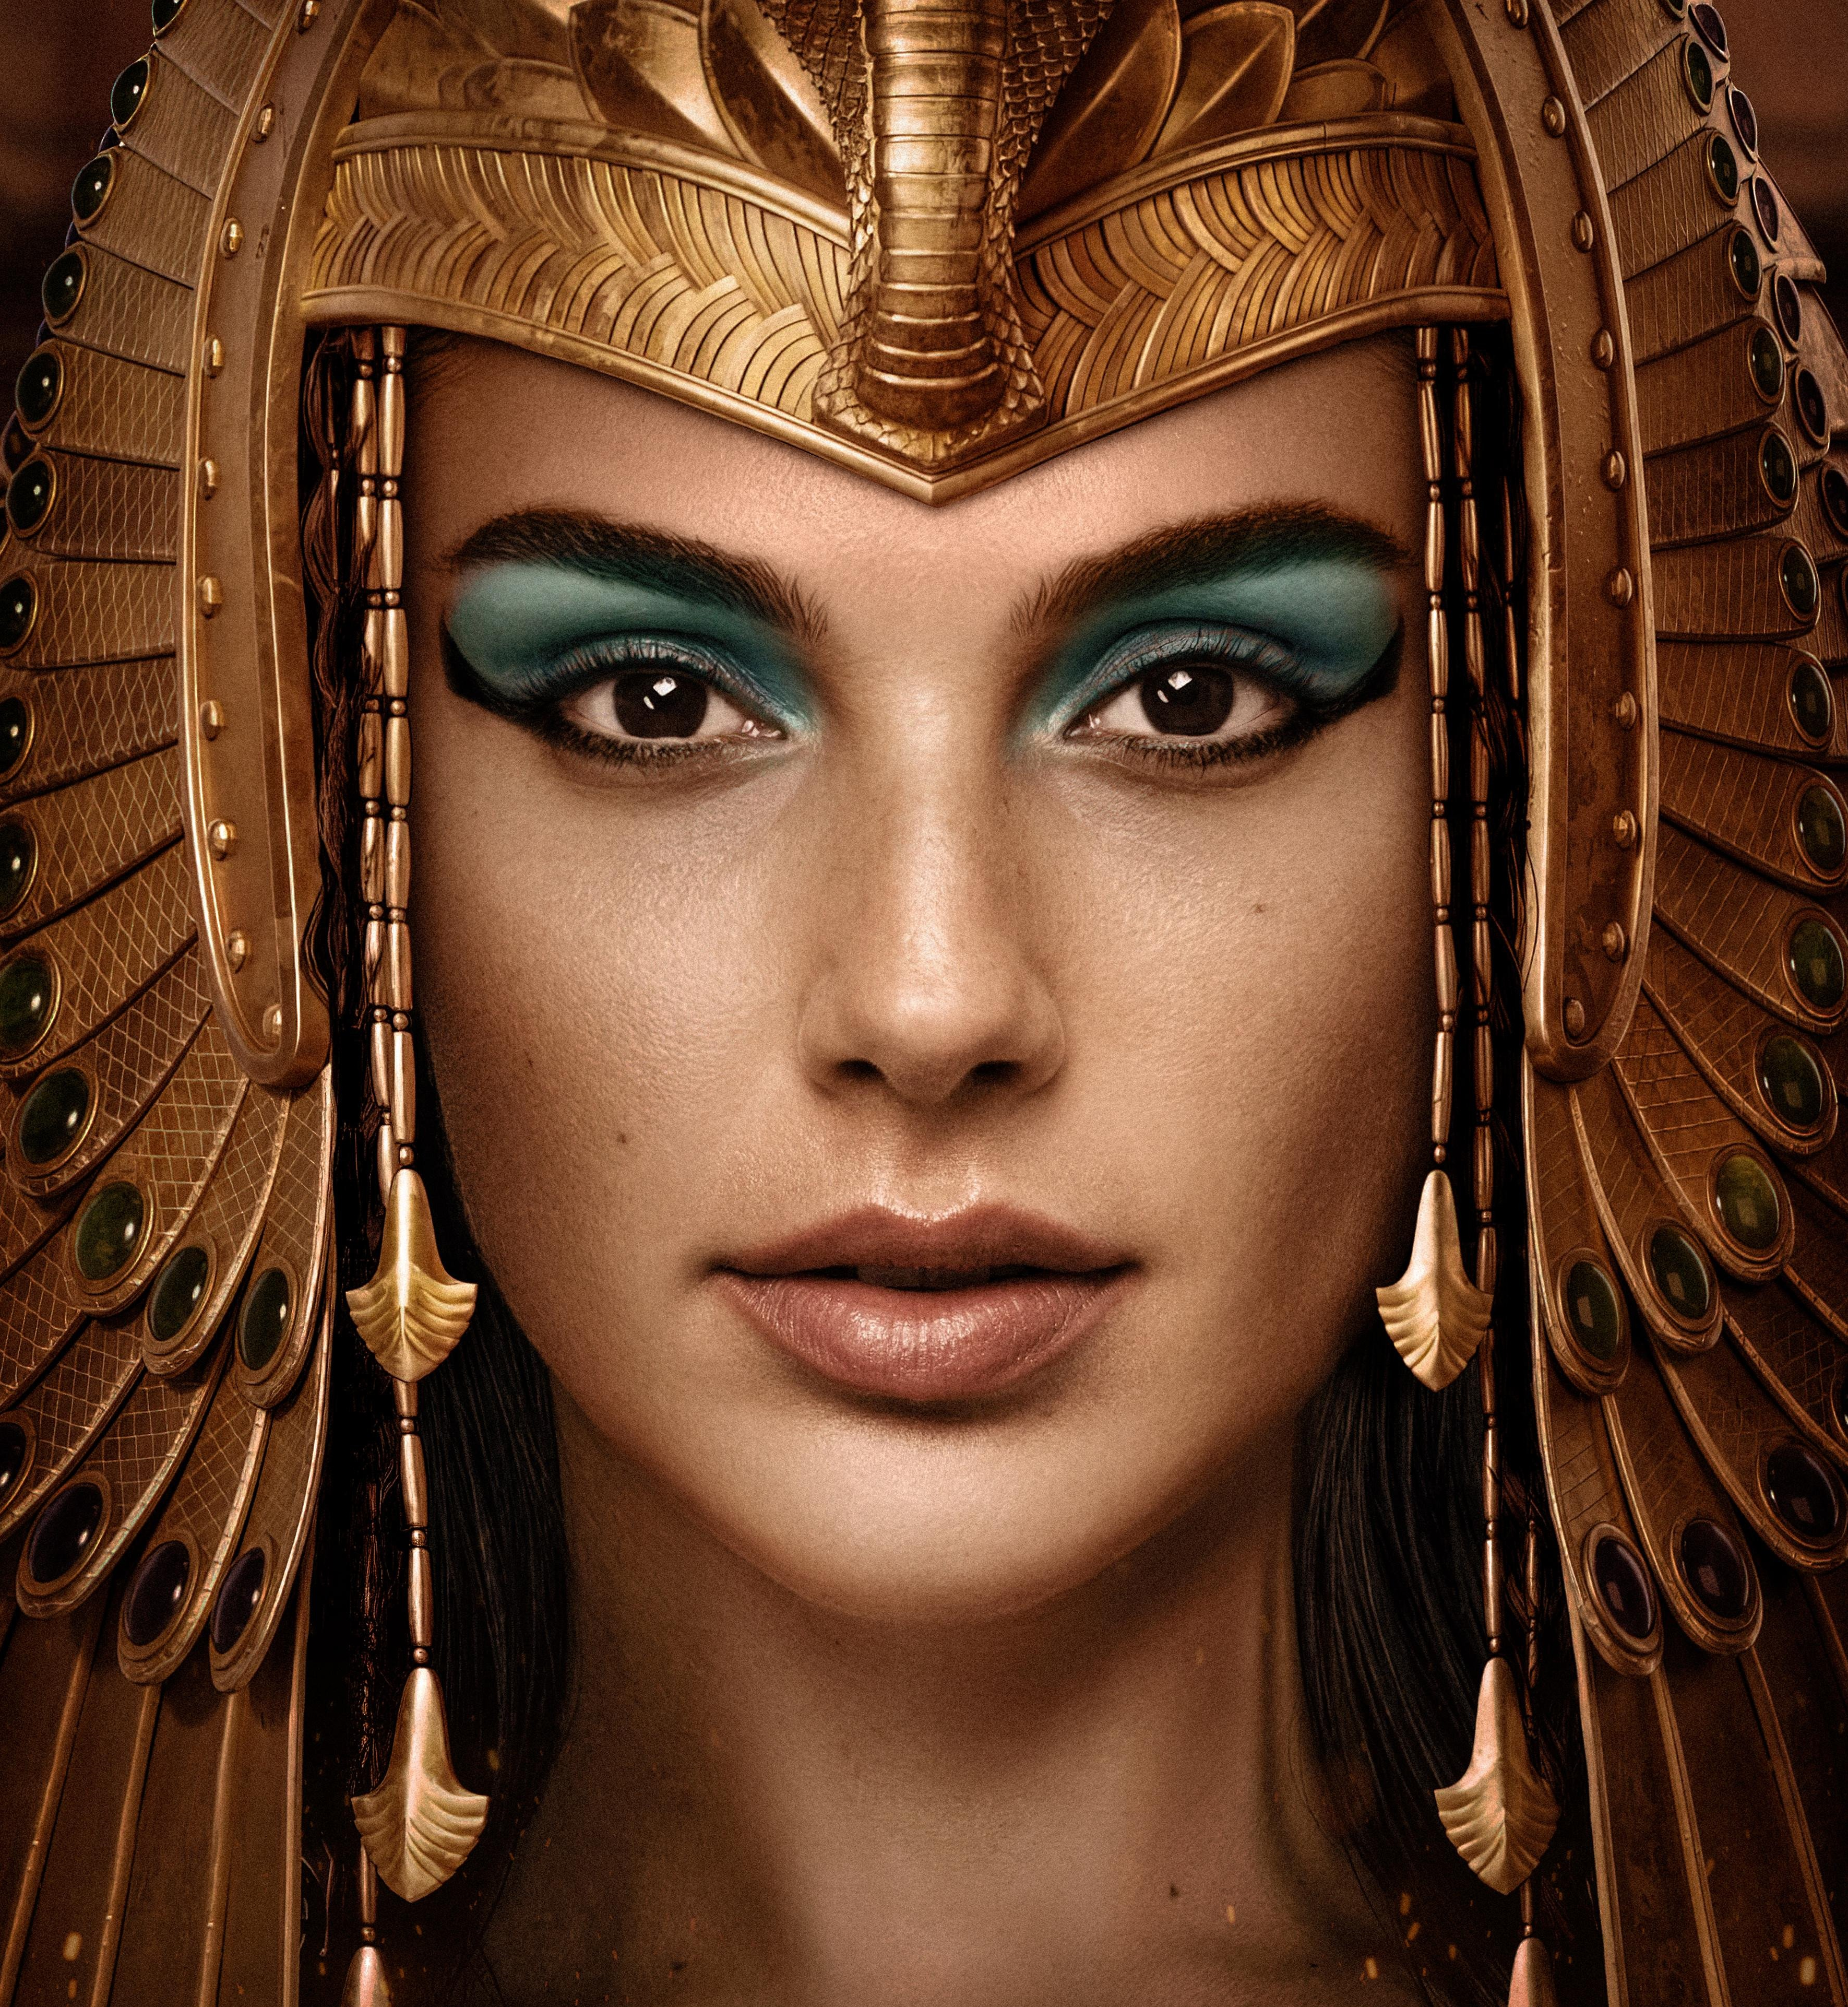

Cost : 3

Range : 1000

Duration : Immediate

Effect : Empress Aleya appears above a Legion of Ahoggya and countermands a Command that has just been issued to them in memory of the consumptions of the Priestesses of Dilinala on Ganga. . Roll for receipt with a modifier of -6 (plus any applicable distance effects). The PSSS paid remains paid. The Command is **issued** but not **executed**, so counts against the 3 / turn restriction but not the per command restriction so if it was Move Command another can potentially be issued the following Cycle.

**Whilte this appears to be an exception to the normal rules preventing the targeting of Hogs in fact it is interfering with the instructions from the CP. It is however an exception to the normal restrictions on the timing of casting of SPOPs.**

**Dark Doom of Ssuganar - Impairment**

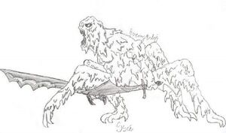

Cost : 2

Range : 1000mm

Duration : 2 turns

Effect : Cinnamon fills the air, blue light shimmers, a ghastly chiming rings out. Target unit halves its Melee **or** its Missile Attack **and** Defence ratings. Deadly Missile or Mighty Fists bonuses are not affected but they may not be cast on a unit affected by Dark Doom.

**Only one Dark Doom can be cast on a unit at any one point in time.**

**[have upgraded this to affect melee as well as missile, for review. Ditto inability to cast DM / MF on a DD unit ]**

**Diaphanous Veil of Pa’iya - Impairment**

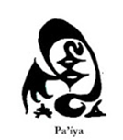

Cost : 2

Range : 1000mm

Duration : Lasts until dispelled or until unit engages in melee combat

Effect : Swirling green and silver shimmers around a chosen unit, with sights of almost unbearable eroticism hanging tantalisingly at the edge of vision.. The unit on which it is cast has -**6 bender** when making a missile attack.

**Additional Veils have no further effect but multiple Veils can be cast. (Dance of the Seven . . )**

**Doomkill - Impairment**

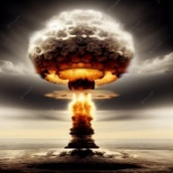

Cost : 4

Range : **1200mm**

Duration : Instantaneous

Effect : A gigantic explosion of Vimuhlan hell strikes enemy units. Treat as a trebuchet attack on two chosen enemy units within **1200mm** of your command stand and 300mm of each other. Normal benders apply with long range being 600-1200mm and short range being 0-300mm from the CP (this can be cast at short range). If cast on a unit is contact everyone in the melee is affected.

**Two Doomkills can impact a given unit in a single Turn but the unit can only be hit once by a given Doomkill.**

**Flight of the Sro - Impairment**

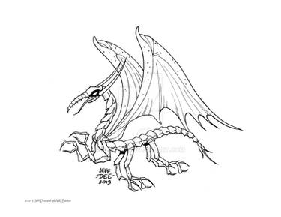

Cost : 0.5

Range : **Anywhere on board**

Duration : Immediate

Effect : Target Hlaka triad imagines a flying Sro is about to interfere with its coloured stones. Roll on the Baring of Buttocks with a -3 modifier ie (9 => 6).

**Only one Flight can be cast on a given Triad in a turn. It may only be cast in the Hlaka phase before the Baring of the Buttocks.**

**Ghastly Embrace of Missum, He Whose Name is Death - Impairment**

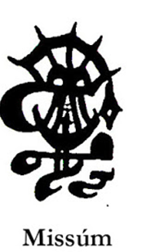

Cost : 1

Range : 1000mm

Duration : Immediate

Effect : A motionless mummified cadaver appears above a chosen unit of unfortunates, who immediately suffer ONE Battlefield Events 1. [Tweaked]

**Only one Embrace can afflict a unit each Turn. Missum and Ghibli can be cast on the same unit in the same turn [subject to review]. This cannot be cast on a unit in contact.**

**Glutinous Fluids of Nere - Impairment**

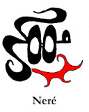

Cost: 2

Range: 1000mm

Duration: 2 Turns

Effect: A bowel loosening tangle of stalks, glistening sticky conduits, bulbous pods and glutinous sacs that make up Lord Nere appears on an individual target unit or two artillery pieces and moves around with it (them). Command failure must be checked with a **-4 bender** as well as any distance effects.

Missile units and artillery fire with a -**3 bender** when suffering this due to the haze of horror. Affected units are treated as being in **Light Cover** if fired on due to the effect of the haze on the enemy. They are also are treated as **Shaken** for bender purposes.

**Only one Glutinous Fluids can be cast on a unit at any one point in time and it**

**cannot be cast on a unit affected by Recondite Obscurities (including a Recondite removed this turn by Cleansing Blade).** **In addition** **it cannot be combined with Unmentionables, the Hlaka do not want to be anywhere near this horror.**

**Hallucinations of Zanatl - Removal**



Cost: 1

Range: 1000mm

Duration: Immediate

Effect: Patterns of light and darkness flicker, and the Mighty Fists is removed.

**This cannot be cast the same turn as the Mighty Fists.**

**Hideous Visions of Kukligash the Eater - Removal**

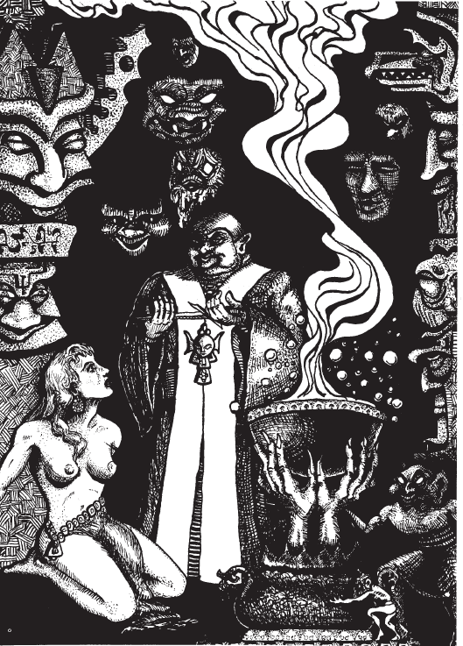

Cost : 2

Range : 1000mm

Duration : Immediate

Effect : Countenance appears and the Diaphanous Veil of Ulela disappears.

**This cannot be cast the same turn as the Diaphanous Veil of Ulela.**

**Lord Mrugga’s Ghibli of the Dry Bay - Impairment**

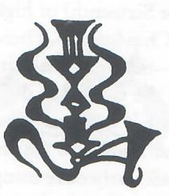

Cost: 2

Range: 1000mm

Duration: Immediate

Effect: An iridescent squamous creature like unto the renowned Flame Dragons of the time of the Dragon Lords hovers above a chosen unit and the scorching wind of the Dry Bay of Ssu’um roars over it doing 2 x Battlefield Event 2. It also dissipates the Curtain of Unseeing for any unit within 500mm of the epicentre.

**Only one Ghibli can be cast on a unit in a single turn. Missum and Ghibli can be cast on the same unit in the same turn [subject to review]. This cannot be cast on a unit in contact.**

**Mouth of Ge’en - Removal**

 change icon

Cost: 1 SSS

Range: 1000mm

Duration: Immediate

Effect: A tower of black mucus surrounded by a miasma of putrefaction and fear appears negates Ssudune the Ravener.

**This cannot be cast the same turn as Ssudune.**

**Recondite Obscurities of Distant Dlash - Impairment**

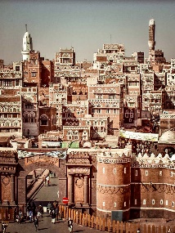 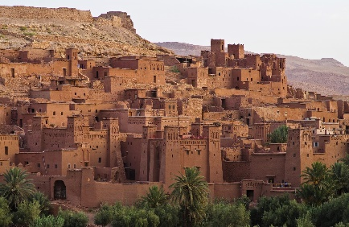

Cost : 2

Range : 750

Duration : Two turns

Effect : The staff of the target legion begin to ponder difficult issues of Livyani philosophy while looking into the availability of tattooists. Any Command issued must roll as per M.2 (Failure to receive commands) **subtracting 5**. If the unit needs to roll on M2 anyway subtract the Recondite modifier as well.

**Only one Recondite can be cast on a unit at any one point in time. It cannot be cast on a unit affected by the Glutinous Fluids of Nere (including a Glutinous removed this turn). It can be combined with Unmentionables (unlike Glutinous).**

**Savage Bite of Ssussu, Eater of the Dead - Impairment**



Cost : 1

Range : 1000mm

Duration : 2 turns

Effect : A huge ophidian beast, apodal and squamous prowls round the target unit which drops one Quality level (ie from Slayer to Smiter, or Smiter to Fighter). Neither Savage Bite or Bluff Cheer are removal PoPs but they effectively negate each other.

**Two Savage Bites can be cast on a unit but a Slayer never drops below Smiter and nothing drops below Fodder.**

**Tkel, Guardian of the Gates of Flame - Removal**



Cost: 1

Range: 1000mm

Duration: Immediate

Effect: The all purifying fire of Jnek’sha appears for a moment and removes Blackness of Kurritlakal or the Darkness of Gereshma’a.

**This cannot be cast the same turn the Blackness / Darkness is cast.**

**NON CONTACT POPS**

**Lascivious Embrace**

**Missum**

**Mrugga**

**Doomkill**

**Note effect of Dark Doom on Fists and watch timing on this.**

**CHANGES**

**Missum reduced to 1 hit**

**Nere simplified and cost reduced**

**Flight of Sro reduced**

**Aleya made a non certainty.**

**Lascivious Embrace permitted after Missum / Mrugga**

**EXTRA CHANGES**

**Ru’utlanesh added to Ssudune to give same bonus to green units**

**Orange units get benefit from Ssudune but not Fanatic status.**

**Benison now Quyove not Ruut**

**Removal of fanatic status defined.**